IBM

**ASSIGNMENT**

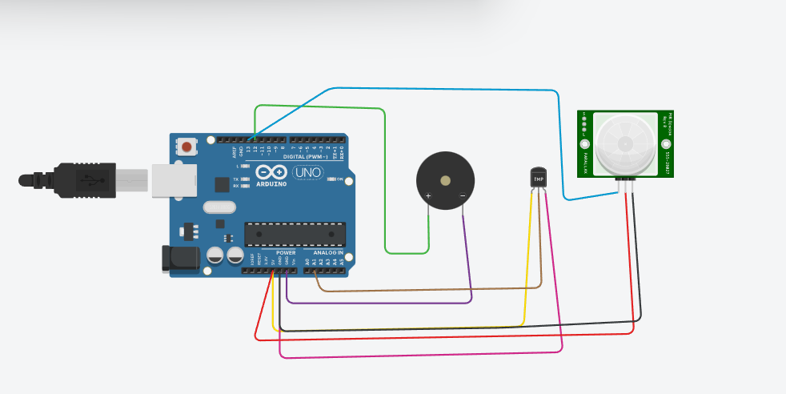

**PROGRAM**

void setup()

{

pinMode(A1,INPUT);

pinMode(12,OUTPUT);

pinMode(13,INPUT);

Serial.begin(9600);

}

void loop(){

{

int temp=analogRead(A1);

temp=temp*0.488;

Serial.print("temp:");

Serial.println(temp);

if(temp <60){

digitalWrite(12,HIGH);

}

else{

digitalWrite(12,LOW);

}

delay(100);

}

int motion=digitalRead(13);

if(motion==HIGH){

digitalWrite(12,HIGH);

tone(13,500);

}

else{

digitalWrite(12,LOW);

}

delay(200);

}

**OUTPUT**

